Soldiers or Spectators?

Supporting TSMP Goal 2: Increase the number of soldiers
Covenant Renewal Day 2013
 | 
The Salvation Army New Zealand, Fiji and Tonga Territory

All Scripture quotations, unless otherwise indicated, are taken from the Holy Bible, New International Version®. NIV®. Copyright © 1973, 1978, 1984 by International Bible Society. Used by permission of Zondervan Publishing House. All rights reserved.
Original idea came from a post in the Canadian Salvationist Website by Major Danielle Strickland (http://salvationist.ca/2011/03/marching-as-to-war-2/)
DEVELOPMENT TEAM: Major Clive Nicolson, Amber Wilkinson, Major Bronwyn Malcolm, Alastair Kendrew
2013

Table of Contents
Introduction 4
Meeting Lead Ideas 6
Soldiers or Spectators 9
Introduction: Option one (no children’s renewal) 9
Introduction: Option two (children’s renewal included) 10
Children’s Renewal 11
Sermon Outline 14
Application 21

Introduction
The first two goals of our Territorial Strategic Mission Plan (TSMP) are to ‘make dynamic disciples of Jesus’ and to ‘increase the number of soldiers’. To achieve these goals, we want to promote soldiership and offer everyone the chance to re-affirm their commitment to God.
This pack provides the basis for a Covenant Renewal Sunday – complete with theme, children’s slot, sermon outline, renewal cards and meeting lead ideas. While clearly focusing on soldiers (senior and junior), the message is intended to be relevant to all congregation members (who may even be inspired to become a soldier).
The theme is Soldiers or Spectators? In July 1861, the first of the major battles of the American Civil War was fought at Bull Run, a stream near the town of Manassas Junction. The American people assumed the whole idea of the civil war was just a passing phase and many people came out with their lawn chairs and picnic baskets to watch the first battle. What everyone discovered—to their horror—was that there was nothing cute or short or fashionable about this conflict. It would turn out to be the bloodiest war in American history.
Picking up on this theme, we’ll compare soldiers and spectators. For the children, we’ll draw out the differences between the two, and encourage the children to choose the harder soldier option.
For the adults, the sermon is based around the Soldier’s Covenant. You are encouraged to use the resources to clearly promote soldiership, while encouraging everyone to reaffirm their commitment to God, in whatever form that takes.
Please use these resources as you find useful and personalise the sermon to reflect your own style and experiences.
Additional Resources  With this booklet, you should have received two sets of Covenant Cards – separate cards for adults and children. | 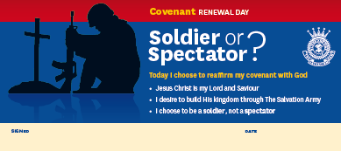 |  | 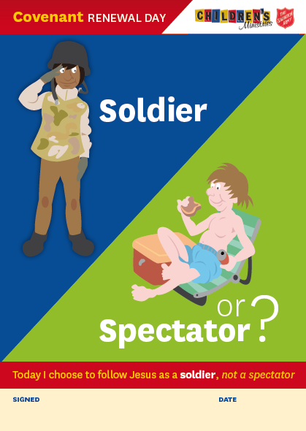
In addition, the intranet contains a range of electronic resources to support this day. Head to https://intranet.sarmy.net.nz/, hover your mouse over the Strategic Mission Plan menu, and choose TSMP Resources Goal Two.
Resources available include:
- Electronic copy of this sermon for editing  - Themed PowerPoint with sermon points  - Themed PowerPoint with images for the children’s renewal  - Background images for advertising or using as a themed background for lyrics. |  | 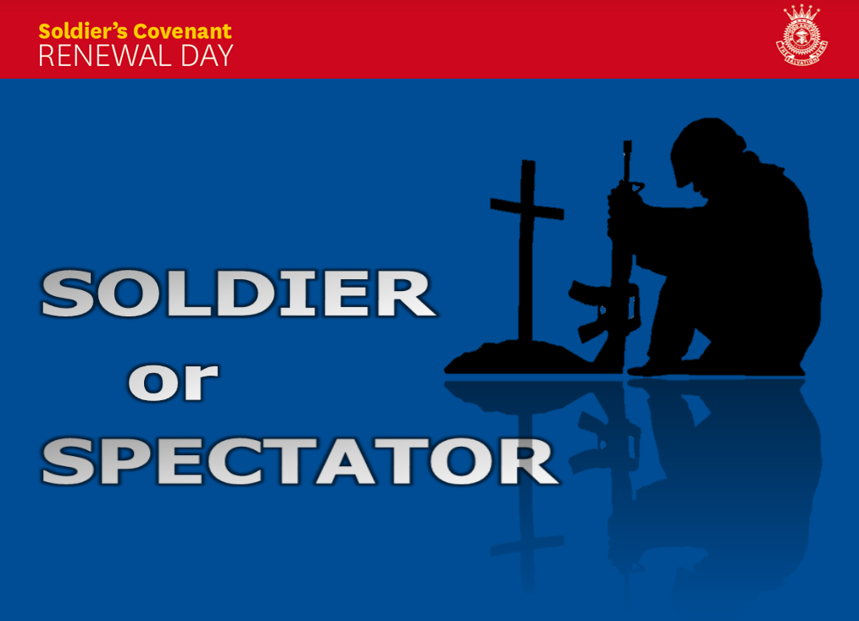

We trust you find this resource useful. We are always keen to receive feedback so that we can improve our service to you. If you have feedback, please send it to tsmp@nzf.salvationarmy.org.

Meeting Lead Ideas
These ideas are based on using the time leading up to the sermon to get people thinking about the topic so that they are more receptive to the message.
Two alternative introductions are provided on the next page. This might be followed by a range of aspects that reinforce the themes of soldiership, Salvation Army history and “soldiers v spectators”.

Ideas for the Middle
- Instead of a Bible reading, read the Soldier’s Covenant
- Testimony from a current soldier
- DVD clip: Not a fan: Either http://www.notafan.com/ or http://www.youtube.com/watch?v=8mQkO8R-aW4
- DVD clip: The Patriot (Pray for the Cause): http://www.wingclips.com/movie-clips/the-patriot/pray-for-the-cause
- DVD clip on William Booth’s Vision of the Lost (On the intranet or as an alternative http://www.youtube.com/watch?v=jzGLWy7b9yQ)
- DVD clips from The Next Step – such as any of the history sessions in Section1: Think It, or the Montages in Section 3: Live It
- Announce a major step forward to be taken by the Corps in the next few months, requiring dedicated soldiers as leaders and workers
- Potential songs about soldiers
  - SASB 687 I’ll stand for Christ
  - SASB 696 Soldiers of our God arise (Storm the forts of darkness)
  - SASB 707 Who is on the Lord’s side?
- More contemporary songs:
  - Our God is Greater (Chris Tomlin)
  - Be thou my vision (Be thou my breastplate, my sword for the fight, thou my whole armour, …)
  - The battle belongs to the Lord (Jamie Owens-Collins)
  - Strong tower (Newsboys)
  - The enemy has been defeated (Hillsong)
  - Holy Ghost (Bjorn Aslaksen) (Holy Ghost, you’re wonderful, … As soldiers in his army, we fight with heart and soul)

Ideas for a Response time
- Two sets of Renewal Cards are provided – for adults and children
- You might also include cards for people to indicate that they are interested in considering soldiership
- Possible response songs
  - SASB 525 Take my life and let it be
  - SASB 786 Take thou my life Lord
  - SASB 474 All to Jesus, I surrender
  - The Potter’s Hand
  - With all I am (Into your hand, I commit again …)
  - Lord I give you my heart
- Songs to finish on a high
  - Mighty to save (Hillsong United)
  - God of this City (Chris Tomlin)
  - Great Awakening (Bankhead, Goudie and Bassett)
  - SASB 734 I’ll go in the strength of the Lord
The Soldier’s Covenant
Having accepted Jesus Christ as my Saviour and Lord, and desiring to fulfil my membership of His Church on earth as a soldier of The Salvation Army, I now by God's grace enter into a sacred covenant.
I believe and will live by the truths of the word of God expressed in The Salvation Army's eleven articles of faith …
I will be responsive to the Holy Spirit's work and obedient to His leading in my life, growing in grace through worship, prayer, service and the reading of the Bible. I will make the values of the Kingdom of God and not the values of the world the standard for my life.
I will uphold Christian integrity in every area of my life, allowing nothing in thought, word or deed that is unworthy, unclean, untrue, profane, dishonest or immoral.
I will maintain Christian ideals in all my relationships with others; my family and neighbours, my colleagues and fellow salvationists, those to whom and for whom I am responsible, and the wider community.
I will uphold the sanctity of marriage and of family life. I will be a faithful steward of my time and gifts, my money and possessions, my body, my mind and my spirit, knowing that I am accountable to God.
I will abstain from alcoholic drink, tobacco, the non-medical use of addictive drugs, gambling, pornography, the occult and all else that could enslave the body or spirit.
I will be faithful to the purposes for which God raised up The Salvation Army, sharing the good news of Jesus Christ, endeavouring to win others to Him, and in His name caring for the needy and the disadvantaged.
I will be actively involved, as I am able, in the life, work, worship and witness of the corps, giving as large a proportion of my income as possible to support its ministries and the worldwide work of the Army.
I will be true to the principles and practices of The Salvation Army, loyal to its leaders, and I will show the spirit of salvationism whether in times of popularity or persecution.
I now call upon all present to witness that I enter into this covenant and sign these articles of war of my own free will, convinced that the love of Christ, who died and now lives to save me, requires from me this devotion of my life to His service for the salvation of the whole world; and therefore do here declare my full determination, by God's help, to be a true soldier of The Salvation Army.
Sermon and Introduction

Soldiers or Spectators
Reading: The Soldier’s Covenant
Note: The topic hinges around a story from the American Civil War. If you are including a Children’s renewal in your meeting, we suggest you tell the story as a children’s story. If not, it needs to be in the meeting introduction. For this reason, you will see two different meeting introduction options.

Introduction: Option one (no children’s renewal)
In a post for the Canadian Salvationist website, Major Danielle Strickland writes …
‘In July 1861, the first of the major battles of the American Civil War between the union and the confederacy was fought at Bull Run, a stream near the town of Manassas Junction.
The American people assumed the whole idea of the civil war was just a passing phase and many people came out with their lawn chairs and picnic baskets to watch the first battle. I’m not kidding. What everyone discovered—to their horror—was that there was nothing cute or short or fashionable about this conflict. It would turn out to be the bloodiest war in American history.
The Bible is clear that we are engaged in a war—not a physical war with guns and bullets, but a very real spiritual war.
Jesus never invited spectators. He wanted disciples. He wanted people who would actively engage the enemy for God’s Kingdom to come. He gave his disciples authority over the enemy and in John 3:8 said that he himself had come to destroy the devil’s work.’
The Salvation Army was raised up as a clear response to that call from Jesus, hence the military metaphor with officers and soldiers grouped in corps, ready to engage in spiritual warfare.
Today is a significant day in The Salvation Army calendar. We call it Covenant Renewal day – a day when we provide an opportunity for everyone to consider their commitment to God, and for Salvation Army soldiers and adherents to consider the covenants they signed and re-commit their promises to God.
So how are we doing? Are we engaged in the war or are we sitting in our lawn chairs, watching from the side while enjoying church as a social club?

Introduction: Option two (children’s renewal included)
In a post for the Canadian Salvationist website, Major Danielle Strickland writes …
The Bible is clear that we are engaged in a war—not a physical war with guns and bullets, but a very real spiritual war.
Jesus never invited spectators. He wanted disciples. He wanted people who would actively engage the enemy for God’s Kingdom to come. He gave his disciples authority over the enemy and in John 3:8 said that he himself had come to destroy the devil’s work.’
The Salvation Army was raised up as a clear response to that call from Jesus, hence the military metaphor with officers and soldiers grouped in corps, ready to engage in spiritual warfare.
Today is a significant day in The Salvation Army calendar. We call it Covenant Renewal day – a day when we provide an opportunity for everyone to consider their commitment to God, and for Salvation Army soldiers, adherents and junior soldiers to consider the covenants they signed and re-commit their promises to God.
So how are we doing? Are we engaged in the war or are we spectators, watching from the side while enjoying church as a social club?

Children’s Renewal

What you need:
- Junior Soldier Power Point Slides (included with this pack)
- Renewal Cards for children
- (optional) Soldier’s equipment, such as a pack, fly (or tarpaulin), survival blanket (or sleeping bag), rations, muesli bars, thermal top, camouflage clothing, boots, helmet, water bottle etc.
- (optional) Picnic basket with nice food, a blanket, sun block, insect repellent, a comfortable chair, etc.

The story:
150 years ago, there was a terrible war in America, known as the American Civil War. America is made up of a whole lot of States and the war basically started because some of the States thought it best to be ruled by a main Government, while others wanted to be able to decide their own rules.
The reason they wanted to make their own rules is because they wanted to be allowed to use slaves. The people in the South mainly grew cotton, and so wanted cheap workers – African slaves. The people in the North didn’t need slaves and so wanted the South to stop using them. They ended up at War.
One of the first battles in the war was at a place called Bull Run.
The American people assumed the war would just be a passing phase; so many people came out with their chairs and picnic baskets to watch the battle. I’m not kidding. Can you imagine it – a whole lot of soldiers down in the valley shooting and fighting each other, while people sat on the surrounding hills watching!
What everyone discovered—to their horror—was that there was nothing nice about this conflict. It would turn out to be the worst war in American history, with more than 600,000 soldiers killed. That’s like everyone in Wellington and Christchurch all killed.

Let’s imagine it’s the day of the battle and you are there, as a soldier [show PowerPoint slide ‘soldier’].
- What is your goal? (to win the war and not get killed)
- What preparation would you have done in the weeks leading up to this battle? (shooting practice, fitness training, healthy food, etc.)
- How are you feeling? (scared – you may die or get badly hurt. You may never see one of your friends or your Dad again; perhaps you believe in what you’re doing and so feel like you’re doing the right thing, or you may be wishing you were somewhere else)
- What do you need to bring with you and why (or take your pack, and pull out items asking why you might need them)?
  - Helmet, bullet proof vest – protect you from bullets
  - Good clothing – you might get muddy, need to jump through gorse bushes, etc., plus keep warm when it is freezing over night
  - Shelter / sleeping – you’ll be sleeping rough, if at all, but will need some shelter and warmth to survive the nights
  - Food rations – high energy, long lasting food. You may have to carry your food for many days.
  - Weapons – a means to attack the enemy.
So our soldier has trained hard, and only has with them what they need to protect themselves and win the battle (and nothing else).

Now let’s imagine you’re at the battle as a spectator [show PowerPoint slide ‘spectator’].
- What is your goal? (to have a great day enjoying the show)
- What preparation would you have done leading up to the battle? (None)
- How are you feeling? (excited)
- What do you bring with you (or take out your picnic items) and why?
  - Nice food and drink – part of having a nice time
  - Games to play – have fun
  - Sun screen, insect repellent, jersey, hat – keep you comfortable
  - Comfortable chairs and blankets – keep you comfortable
You could summarise all of this as making sure you are comfortable and have a good time. Your biggest danger is probably an insect bite or too much sunshine!

The Bible tells us we are in a war – a spiritual war.
- Who are we fighting against? (Satan)
- How does he attack us? (doubts, temptation, guilt, bad friends, etc.)
- If a soldier needs to protect themselves and win the battle, how do we protect ourselves in our spiritual war? (pray, read our Bible, choose good friends, be careful where we go and what we do, ask for forgiveness when we slip up, etc.)
- How do we win the war? (pray, be bold, tell our friends about Jesus and invite them to our church).

Those of you that made the Junior Soldier promise committed to being a soldier – someone who knows they’re in a spiritual battle, who has chosen to be on the side of Jesus and who is training themselves for the battle. Others of you may not have made the Junior Soldier promise, but you have also decided that you want to follow Jesus. Let’s have a look at the Junior Soldier promise [show PowerPoint slide ‘My Promise’]:
Junior Soldier Promise
I know that Jesus is my Saviour from sin.
I have asked him to forgive my sins, and I will trust him to keep me good.
By his help, I will be his loving and obedient child, and will help others to follow him.
I promise to pray, to read my Bible, and to lead a life that is clean in thought, word and deed.
I will not use anything that may injure my body or my mind, including harmful drugs, alcohol and tobacco.
It’s pretty hard to be the person we know Jesus wants us to be all the time. All of us sometimes fall into the trap of becoming a spectator instead of a soldier. So today, we want you to think about whether you want to be a spectator or soldier.
[Show PowerPoint slide –‘Soldier or Spectator’]
We have some cards here for you to take if you want to. They simply say ‘Today, I choose to be a soldier, not a spectator.’ If this is true for you, please grab a card and hold it, and then I will pray. There’s space for you to sign it later.
[Optional: there is also space for the children to sign the card – however, if you have called the children forward for a children’s story, you need to be careful not to force them into signing something they may not want to. Therefore, you may prefer to just pray for the children, and ask them to sign the cards later, or only invite children forward if they would like to take a card and sign it.]

Sermon Outline
[Note: The symbol 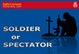 shows when to move forward the text on the Power Point slides. It is not intended you read the Soldier’s Covenant clauses aloud.]

Introduction
George Whitfield conducted outdoor evangelistic campaigns in the 1700’s. Although thousands responded to his Gospel message, when asked how many were converted after one of his sermons, he replied, “We’ll know in five years.” The passing of time should reveal which decisions are superficial and which are genuine, lasting commitments to Christ.
As has been mentioned, today is Covenant Renewal Day, but it’s not just for people who have chosen to become a soldier within The Salvation Army – it’s a chance for all of us to reflect on commitment to God and for those of us who have chosen to follow Him, whether this commitment is growing with the passing of time. Our theme is ‘soldiers or spectators’ based on the people who took lawn chairs and picnic baskets to watch the first major battle of the American Civil War.
Please note that it is not the intention to imply that if you are not a soldier, you must be a spectator! We are talking about soldiers of Jesus – people who are choosing to follow Jesus, of which Salvation Army soldiers should be a subset.

Salvation army soldiership
The Salvation Army’s concept of soldiership is based on the biblical metaphor of being soldiers fighting in a spiritual battle.
To become a Salvation Army soldier, a person signs a document known as the Soldier’s Covenant – containing the eleven statements of Salvation Army doctrine and a series of statements relating to the role of a soldier.
The Soldier’s Covenant starts with the words projected on screen.
‘Having accepted Jesus Christ as my Saviour and Lord, and desiring to fulfil my membership of His Church on earth as a soldier of The Salvation Army, I now by God's grace enter into a sacred covenant.’
A soldier of The Salvation Army is first and foremost a committed disciple of Jesus. Secondly, they are committed to serving God in The Salvation Army, but this is much more than simply becoming a member. The covenant clauses cover almost every aspect of life.
When someone becomes a soldier, they join the world-wide fellowship of soldiers currently serving in 126 countries.
Using the Soldier’s Covenant as a guide let’s look at four keys to being a soldier.

1. Acknowledge there is a spiritual war
There’s not much point being a soldier if there will never be a battle for you to fight in. Most of us have little interest in becoming a soldier in the military. We are pretty confident our country will not be attacked and we have no interest in risking our lives in someone else’s conflict. Yet, if we were invaded tomorrow and our families lives depended on it, I’m sure we would suddenly get involved.
The Bible is clear that we are engaged in a war—a spiritual war. In Ephesians 6:11-12, the apostle Paul tells us to:
‘Put on the full armour of God, so that you can take your stand against the devil’s schemes. ¹² For our struggle is not against flesh and blood, but against the rulers, against the authorities, against the powers of this dark world and against the spiritual forces of evil in the heavenly realms.’
It’s pretty easy to agree we live in a dark world. How does someone plant a bomb at the end of a marathon, or rape a tourist? As a country, we have major problems with suicide and child abuse. Children go to school hungry.
While these are clear example of extreme evil, our fight is typically much more subtle than that. In 1 Peter 5:8 we read :
‘Be alert and of sober mind. Your enemy the devil prowls around like a roaring lion looking for someone to devour.’ (1 Peter 5:8)
The devil isn’t some funny red guy holding a pitch fork, but a real spiritual being who wants nothing more than to stop us being in close communion with God. Jesus said “The thief comes to kill and destroy” and he will do that by any means that he can. So he attacks us with doubts and tempts us to do things we shouldn’t, or not do things we should, and then ‘gotcha’ and we feel guilty.
The Christian soldier recognises they are in a spiritual war and takes the threat of the devil seriously. On the other hand, the spectator does not see themselves as participants in a war. They may believe in God and feel that is enough to secure a ticket to heaven. They’ve given in to spiritual attack, so have little further need to rely on God for his power and protection.
In the post I referred to earlier about people watching the battle, Danielle Strickland continues …
‘So is soldiership outdated? An old metaphor? The only way that soldiership can be outdated is if the war is no longer real. Even asking the question could put us in danger of being arrogant or ignorant enough to believe that there is some cute, easy and metaphorical war being waged and that we can simply find a pew in a lovely church down the street from our cul-de-sac and watch the entertainment.
We aren’t spectators. This isn’t a cute, metaphorical war—it’s the real thing. We are called to help, to enlist, to fight. This is the call of true discipleship and our great heritage of Salvationism.’

2. Train for battle
If you knew you were going to be in a physical battle, how much effort would you put into your preparation? Each year, a number of sports people agree to participate in the ‘Fight for Life’ charity boxing matches and the feedback repeatedly is that the participants have never trained so hard.
For example, you would expect Hika Elliot, a professional rugby player and fringe All Black to be exceptionally fit. Yet, in training for the 2012 Fight for Life, Hika professed he was fitter than he had ever been. Similarly rugby league player Manu Vatuvei was reported as being in the best shape of his decade long career after shedding six kilograms in five weeks – just for a charity boxing match.
Having confirmed The Salvation Army’s 11 statements of faith, The Soldier’s Covenant outlines building blocks essential to the spiritual battle.
I will be responsive to the Holy Spirit's work and obedient to His leading in my life, growing in grace through worship, prayer, service and the reading of the Bible.
The Christian soldier knows that the battle will at times be fierce, and so they put in preparation to give them the best chance of survival and success.
In a recent research project of 80,000 Christians, almost everyone surveyed admitted to a time when they were stalled in their faith. The number one factor that got them going again was re-starting their personal spiritual practices – reading their Bible and praying, etc. (Reveal: Follow Me, p90).
A second interesting finding was that while new believers benefit enormously from training and small groups, mature believers need something more – ‘spiritual risk taking’. People only grew to the highest level if they were being stretched to the point where they needed to rely on God, such as sharing their faith with friends, or leading a ministry.
The Christian soldier recognises that their power source is God so they train hard for this connection. As they pray and become familiar with the Bible, they find it easier to resist the devil and discern the Holy Spirit’s leading in their life. And then as they serve and obey the Holy Spirit, their faith grows and relationship deepens as they rely on Him.
The spectator on the other hand is not concerned about the war. They’re not seeking to follow the Holy Spirit’s leading, and so have little need for prayer, spiritual discipline or risk taking.

3. Throw off anything that hinders
At a recent school camp, one of the boys was struggling under the load of his heavy bag, two hours into a day tramp. When the leaders looked into his bag, they found he was still carrying all his wet swimming gear from the day before!
The Christian soldier doesn’t want anything in their lives that will detract them or hold them back from their mission. The Bible puts it this way:
‘Let us throw off everything that hinders and the sin that so easily entangles’ (Hebrews 12:1) and
The next clauses of The Soldier’s Covenant sum up a variety of issues that may detract or hold back a Christian soldier. The first relates to Christian integrity.
I will uphold Christian integrity in every area of my life, allowing nothing in thought, word or deed that is unworthy, unclean, untrue, profane, dishonest or immoral.
Let us look at what Paul had to say about living a life of integrity:
‘³ But among you there must not be even a hint of sexual immorality, or of any kind of impurity, or of greed, because these are improper for God’s holy people. ⁴ Nor should there be obscenity, foolish talk or coarse joking, which are out of place, but rather thanksgiving. ⁵ For of this you can be sure: No immoral, impure or greedy person–such a man is an idolater–has any inheritance in the kingdom of Christ and of God.’ Ephesians 5:3-5
I am always amazed at how people try to make deals with God. Some people think that God will overlook the “few” sins in their lives because of all the good things they have been doing. Other’s think that because they don’t commit any “big sins”, they do not have to worry about the small things. But Paul made it clear that there could not even be a “hint” of sin in their lives. The list he provided encompasses many different kinds of selfishness; sexual impurity, greed and even bad language and foul jokes. The “little things” really do matter!
I wonder if ‘lethargy toward sin’ is one of the biggest issues in the church today. Why does the Bible make it so clear that this is critical for the Christian?
First, sin will hold you back. You will feel guilty; you will worry about being exposed; you will be distracted from the battle. And when you are exposed, your entire faith and ministry can quickly come crashing down.
Second, as a Christian soldier, you are an ambassador for God, living by different standards. Jessie Ryder and Zac Guildford are two sports people who know what it’s like to face media scrutiny. Both have had a series of off-field discretions that have led to stand downs for breaking team protocols. One might argue if they were only spectators, few would care that they got drunk and did stupid things. But they’re not spectators, so the expectations are different.
One of the biggest turn offs for people outside the church is the perceived hypocrites in the church. Every time you say you profess a faith in God, and then act differently, people are noticing, and turning away. And we will each be judged for this in time.
This concept of integrity flows through into every area of our lives.
I will maintain Christian ideals in all my relationships with others; my family and neighbours, my colleagues and fellow salvationists, those to whom and for whom I am responsible, and the wider community.
I will uphold the sanctity of marriage and of family life. I will be a faithful steward of my time and gifts, my money and possessions, my body, my mind and my spirit, knowing that I am accountable to God.
The spectator simply lives for themselves, but the Christian soldier is accountable to God. They can’t manipulate people to get their way in business. Or talk about people behind their backs. Or spend all their time at work, leaving little time for our family. Or succumb to materialism.
These are tough clauses and they don’t get any easier. The next one is to keep away from anything that might enslave you.
I will abstain from alcoholic drink, tobacco, the non-medical use of addictive drugs, gambling, pornography, the occult and all else that could enslave the body or spirit.
The Salvation Army is well known for its stance on drinking and smoking, but few people understand why. It’s because we don’t want to be involved in anything that could affect our self-control or enslave us (perhaps Facebook™ should be added).
Thousands of lives are ruined each year in our country by each of these issues, but we’re going to focus briefly on one that is not spoken about so often.
A range of surveys claim that 50 per cent of Christian men surveyed view pornography regularly. [Google search on ‘Christian pornography statistics’ for examples such as PromiseKeepers, Focus on the Family and Christianity Today].
But this is not just a problem for men. Other surveys reveal that one in three visitors to adult websites are women. [e.g. Internet Filter Review]
Mike Genung is the pastor of a large church in the USA. He could not believe these statistics, so he decided to survey his own congregation. He writes: ‘Most of the men in my church are in their late 30s to early 40s, married, and the father of little ones. They have successful careers making good money and are involved in ministry. I couldn’t picture so many of these men I sit next to every Sunday leering at porn.’ To his amazement, 25 per cent had looked at porn within the past 30 days, and 61 per cent within the year.
Pornography viewing is not a harmless act for the sexually frustrated. It is highly addictive and will ruin your relationships with the people you love. If you are involved in pornography, please seek help.

4. Engage in the fight
The final section of the Soldier’s Covenant could be described as a call for becoming engaged in the fight.
I will be faithful to the purposes for which God raised up The Salvation Army, sharing the good news of Jesus Christ, endeavouring to win others to Him, and in His name caring for the needy and the disadvantaged.
I will be actively involved, as I am able, in the life, work, worship and witness of the corps, giving as large a proportion of my income as possible to support its ministries and the worldwide work of the Army.
I will be true to the principles and practices of The Salvation Army, loyal to its leaders, and I will show the spirit of salvationism whether in times of popularity or persecution.
There is so much good content in these statements that we could write a sermon on each sentence … You’ll be pleased I’ll only touch on three.
- How many non-Christian friends do you have and how much time do you spend with them? If we are serious about endeavouring to win others to Jesus, we need to be intentional. [You could use this slot to promote the Friendships that Count course (download from the intranet).]
- The Christian soldier realises that they can achieve a lot more with others than on their own, so they get involved in their church and support it financially. Clearly a church needs money to pay for the building and staff, but more than that, you are acknowledging God and investing in what you believe is important.
- Being loyal to our leaders. This is a hard one but important for all of us. We need to be loyal to each other, and loyal to our divisional and territorial leaders; not enjoying roast officer for lunch.
As Jesus said in Matthew 12:25
‘Every kingdom divided against itself will be ruined, and every city or household divided against itself will not stand.’ (Matthew 12:25)
How engaged are you in the fight? Are you in the trenches, giving your all, or on the hill with your picnic enjoying the spectacle?

Summary
The Christian soldier takes the spiritual war seriously. They train hard for the battle, get rid of anything that might hinder them, and engage in the fight.
A missionary named Herbert Jackson tells a story about when he went into the mission field and someone gave him a car. The problem was that the car needed to be pushed to start, so each day, he would either have to park it on a hill or leave it running so he could get around to his duties. He did this for two years until illness forced him to leave and a new missionary was sent to replace him. On the day he was leaving, Mr. Jackson was showing the new how to start the car, when the new guy popped the hood and said, "I think this is your problem." And he reached down, connected a loose wire and the car started right up.
The power was there the whole time, but a loose connection was the problem.
Each of us wants to serve God wholeheartedly. But over time, we can get tired, or disillusioned, or side-tracked, or even bored.
Is this your experience of God? Are you connected into His power, or are you trying to do things in your own strength? Mark Batterson writes:
‘Prayer is the difference between the best you can do and the best God can do. So if we’re not praying, then the best we can do is the best we can do, and that’s not good enough.
When you stop praying, it takes the supernatural element out of what we’re doing and the church becomes a club. There’s no conviction of the Holy Spirit, no miracles—then the church stops being a movement and becomes a museum to what God has done in the past.’
The Christian soldier knows they’re in a spiritual war.
Knowing they can’t fight on their own, they plug into God’s power and rely on Him as they serve in the battle.
A spectator doesn’t need God’s power. Which are you?

Application
(Display the card)
In a moment, you’ll have the chance to respond by coming forward and signing a card as a public sign of your commitment to God. The card simply says Today I choose to reaffirm my covenant with God and choose to be a soldier, not a spectator.
Your covenant may be as a Salvation Army soldier or adherent member. It may simply be a promise you made to God to follow Him, or you may want to make such a promise for the first time today. It doesn’t matter what your promise is – we want you to have the chance to reaffirm and strengthen your desire to follow Jesus.
If you would like to pray, you are welcome to kneel at the mercy seat, and someone will come and pray with you.
Perhaps you’ve never realised you are in a spiritual war, or never chosen to side with Jesus. If you have decided you would like to follow Him, please come forward and someone will pray with you.
Perhaps you have been trying to follow Jesus, but you’ve been doing so in your own strength. You may feel tired or scarred from battle. You need the power of the Holy Spirit. If this is how you are feeling, I ask you to not leave today without having someone pray for you to be filled (or refilled) with the Holy Spirit.
Perhaps you’re involved in sin that you just can’t shake. You’ve been trying to fight it on your own. Now’s a great chance for you to repent and ask God to give you His power.
If you are not a soldier, perhaps today you feel God prompting you to consider soldiership? If so, please come and talk to me afterwards.
Are you a soldier or a spectator? Please come forward and sign a renewal card as a reminder of your decision today.
(Display the promise)

We recognise that many of these songs are not particularly ‘contemporary’ – but we have struggled to find good modern songs with a spiritual warfare or commitment theme.

